**Ayesha Zubair**

**52916**

**Lab Tasks**

**Task 1: (OR Operation)**

START:

INP

STA NUM

INP

OR NUM

OUT

HALT

NUM: .data 1 0

**Output:**

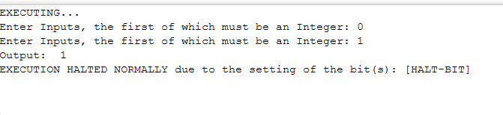According to the truth table of OR operation, when any one input is 1, the output is 1.

The inputs were 0 and 1, so the output is 1.

**Task 2: (NAND)**

START:

INP

STA NUM

INP

NAND NUM

OUT

HALT

NUM: .data 1 0

**Output:**

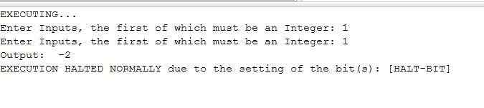

NAND is the opposite of AND.

When any one of the input is 0, the output is 1 and when the inputs are 1 and 1, the output is 0.

Hence the output is 0.

**Task 3: (NOR)**

START:

INP

STA NUM

INP

NOR NUM

OUT

HALT

NUM: .data 1 0

**Output:**

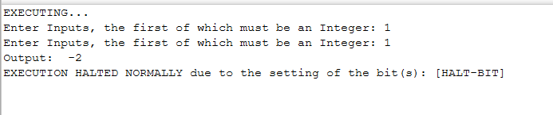

NOR is the opposite of OR.

When both inputs in OR are 1, it gives the output 1, but in case of NOR, it gives output 0.

**Task 4 : (XOR)**

START:

INP

STA NUM

INP

XOR NUM

OUT

HALT

NUM: .data 1 0

**Output:**

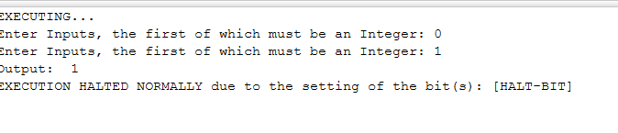

When both inputs in XOR are different, output is 1.

When both inputs are same, the output is 0.

Since both inputs are different, the output is 1.

**Task 5: (NOT)**

START:

INP

STA NUM

NOT NUM

OUT

HALT

NUM: .data 1 0

**Output:**

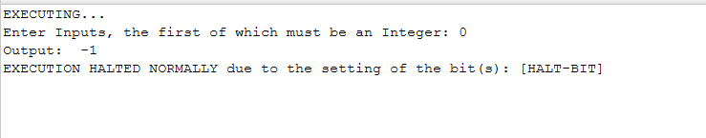

NOT inverts the input.

If input is 0, output is 1 and when input is 1 the output is 0.